Lab 4

Title:
To write HTML code to create the given table design

1. Objective:
The objective of this lab work is to design and create a complex table structure using HTML. This lab focuses on the use of table-related attributes such as rows, columns, row spanning, column spanning, and basic styling to represent structured academic data.

2. Tools / Software Used:
- Operating System: Windows / Linux / macOS
- Text Editor: VS Code / Notepad++ / Notepad
- Web Browser: Google Chrome / Mozilla Firefox

3. Theory:
HTML tables are used to display data in rows and columns. The <table> tag is used to create a table, while <tr>, <td>, and <th> are used to define rows, data cells, and header cells respectively.
To create complex table designs, HTML provides attributes like:
- rowspan to merge rows
- colspan to merge columns
- border, cellspacing, and cellpadding to control table appearance
CSS can be used to improve readability by aligning text and applying font styles. In this lab, internal CSS is used to make headings bold and center-aligned.

4. Algorithm / Procedure:
- Create a new HTML file.
- Define the basic structure of the HTML document.
- Add internal CSS for styling table content.
- Create a table using the <table> tag.
- Use <tr> and <td> tags to define rows and columns.
- Apply rowspan and colspan to merge cells where required.
- Insert academic performance data into the table.
- Save the file and open it in a web browser to view the table design.

5. Source Code:

<html>
<head>
<meta charset="UTF-8">
<meta name="viewport" content="width=device-width, initial-scale=1.0">
<title>Table Practice</title>
<style>
.bc {
text-align: center;
font-weight: bold;
}

.b {
font-weight: bold;
}
</style>
</head>

<body>
<center>
<h1>Table Practice</h1>
<table border="1" cellspacing="0" cellpadding="10" width="50%">
<tr>
<td rowspan="3" class="bc">Department</td>
<td rowspan="3" class="bc">Program</td>
<td colspan="8" class="bc">Semester-Wise Performance</td>
<td rowspan="3" class="bc">Grand Average</td>
</tr>
<tr>
<td colspan="4" class="bc">Odd Semesters</td>
<td colspan="4" class="bc">Even Semesters</td>
</tr>
<tr>
<td class="bc">Sem I</td>
<td class="bc">Sem II</td>
<td class="bc">Sem III</td>
<td class="bc">Sem IV</td>
<td class="bc">Sem V</td>
<td class="bc">Sem VI</td>
<td class="bc">Sem VII</td>
<td class="bc">Sem VIII</td>
</tr>
<tr>
<td rowspan="4">Computer Science</td>
<td>Bsc CSIT</td>
<td>78</td>
<td>67</td>
<td>89</td>
<td>74</td>
<td>84</td>
<td>57</td>
<td>76</td>
<td>45</td>
<td>76.75</td>
</tr>
<tr>
<td>BCA</td>
<td>84</td>
<td>78</td>
<td>74</td>
<td>57</td>
<td>67</td>
<td>89</td>
<td>45</td>
<td>76</td>
<td>72.38</td>
</tr>
<tr>
<td>Msc CS</td>
<td colspan="2">78</td>
<td colspan="2">57</td>
<td colspan="2">76</td>
<td colspan="2">45</td>
<td>76.75</td>
</tr>
<tr>
<td colspan="9" class="b">Department Average</td>
<td class="b">76.82</td>
</tr>
<tr>
<td rowspan="3">Management</td>
<td>BBA</td>
<td>78</td>
<td>67</td>
<td>89</td>
<td>74</td>
<td>84</td>
<td>57</td>
<td>76</td>
<td>45</td>
<td>76.75</td>
</tr>
<tr>
<td>MBA</td>
<td colspan="4">78</td>
<td colspan="4">82</td>
<td>76.75</td>
</tr>
<tr>
<td colspan="9" class="b">Department Average</td>
<td class="b">76.82</td>
</tr>
<tr>
<td colspan="10" class="bc">Overall Institutional Average</td>
<td class="b">76.13</td>
</tr>
</table>
</center>
</body>

</html>

Screenshort:

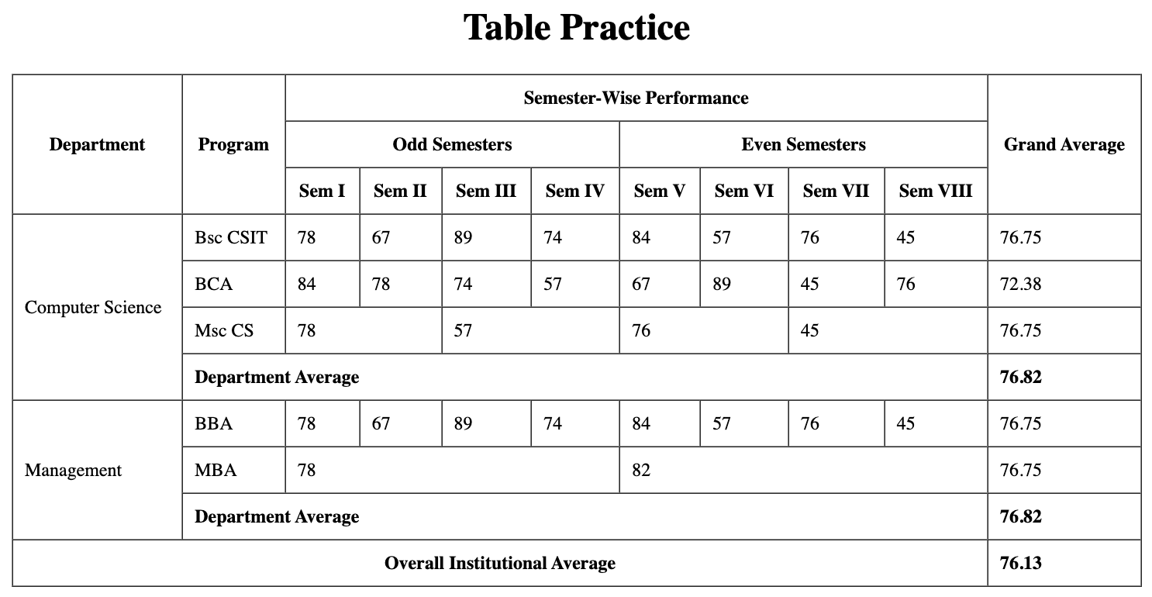

6. Output:
The output is a neatly structured table displayed in a web browser showing department-wise and program-wise semester performance, department averages, and overall institutional average using merged rows and columns.

7. Conclusion:
In this lab work, a complex table design was successfully created using HTML table elements. The use of rowspan and colspan helped in organizing large datasets effectively. This lab improved understanding of HTML tables and their practical application in representing structured academic information.
Print below…..

5. Source Code:

<html>
<head>
<meta charset="UTF-8">
<meta name="viewport" content="width=device-width, initial-scale=1.0">
<title>Table Practice</title>
<style>
.bc {
text-align: center;
font-weight: bold;
}

.b {
font-weight: bold;
}
</style>
</head>

<body>
<center>
<h1>Table Practice</h1>
<table border="1" cellspacing="0" cellpadding="10" width="50%">
<tr>
<td rowspan="3" class="bc">Department</td>
<td rowspan="3" class="bc">Program</td>
<td colspan="8" class="bc">Semester-Wise Performance</td>
<td rowspan="3" class="bc">Grand Average</td>
</tr>
<tr>
<td colspan="4" class="bc">Odd Semesters</td>
<td colspan="4" class="bc">Even Semesters</td>
</tr>
<tr>
<td class="bc">Sem I</td>
<td class="bc">Sem II</td>
<td class="bc">Sem III</td>
<td class="bc">Sem IV</td>
<td class="bc">Sem V</td>
<td class="bc">Sem VI</td>
<td class="bc">Sem VII</td>
<td class="bc">Sem VIII</td>
</tr>
<tr>
<td rowspan="4">Computer Science</td>
<td>Bsc CSIT</td>
<td>78</td>
<td>67</td>
<td>89</td>
<td>74</td>
<td>84</td>
<td>57</td>
<td>76</td>
<td>45</td>
<td>76.75</td>
</tr>
<tr>
<td>BCA</td>
<td>84</td>
<td>78</td>
<td>74</td>
<td>57</td>
<td>67</td>
<td>89</td>
<td>45</td>
<td>76</td>
<td>72.38</td>
</tr>
<tr>
<td>Msc CS</td>
<td colspan="2">78</td>
<td colspan="2">57</td>
<td colspan="2">76</td>
<td colspan="2">45</td>
<td>76.75</td>
</tr>
<tr>
<td colspan="9" class="b">Department Average</td>
<td class="b">76.82</td>
</tr>
<tr>
<td rowspan="3">Management</td>
<td>BBA</td>
<td>78</td>
<td>67</td>
<td>89</td>
<td>74</td>
<td>84</td>
<td>57</td>
<td>76</td>
<td>45</td>
<td>76.75</td>
</tr>
<tr>
<td>MBA</td>
<td colspan="4">78</td>
<td colspan="4">82</td>
<td>76.75</td>
</tr>
<tr>
<td colspan="9" class="b">Department Average</td>
<td class="b">76.82</td>
</tr>
<tr>
<td colspan="10" class="bc">Overall Institutional Average</td>
<td class="b">76.13</td>
</tr>
</table>
</center>
</body>

</html>

Screenshort:



